**ECE 560B6 Lab 3 Report**

**Objective:**

To design a polarization-Dependent MRR and perform 3D FDTD simulation of directional couplers in MRRs.

**Objects used:**

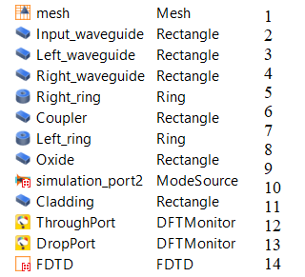

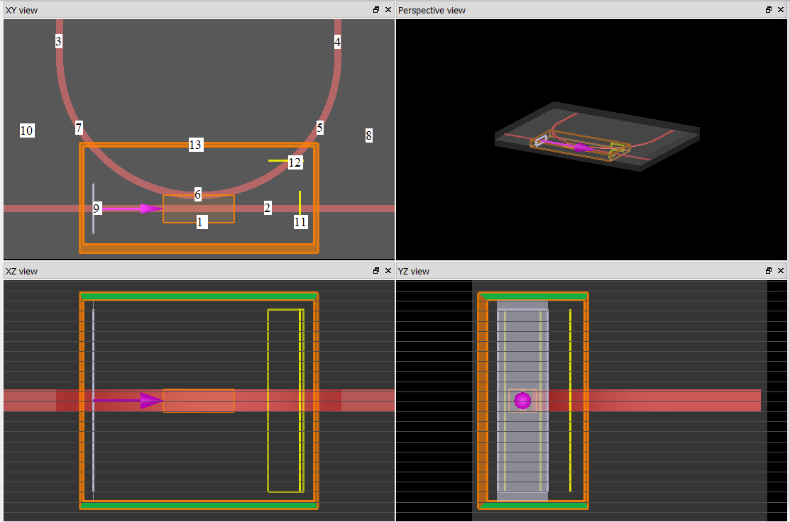

**Approach:**

My script accepts all the parameters mentioned in the description:

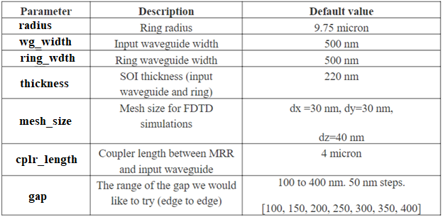

Over the past few weeks, I performed a few simulations changing different variables and marked the changes in coordinates in each object in the object tree. Then I analyzed these changes and constructed mathematical equations for changes in each object for the respective change in each parameter. The script was done with the help of tutorials provided by the Lumerical website and the scripts used in previous labs. Waveforms were achieved for all the combinations of gaps and coupler lengths and have been provided below. The script and the executables are provided in the zip file.

**Output:**

|  |  |  |  |  |  |
| --- | --- | --- | --- | --- | --- |
| Coupler length =0  Coupler Length = 0 | TM mode | | | | |
| Gap | Drop port | Through port | SQRT (Drop Port) | SQRT (Through Port) |
| 0.1 | 0.794361 | 0.202449 | 0.8912693196 | 0.4499433298 |
| 0.15 | 0.628928 | 0.36862 | 0.7930498093 | 0.6071408403 |
| 0.2 | 0.445783 | 0.552427 | 0.6676698286 | 0.7432543306 |
| 0.25 | 0.305637 | 0.69281 | 0.5528444628 | 0.832352089 |
| 0.3 | 0.202673 | 0.795919 | 0.4501921812 | 0.8921429258 |
| 0.35 | 0.131865 | 0.866776 | 0.3631322073 | 0.9310080558 |
| 0.4 | 0.0851848 | 0.913513 | 0.2918643521 | 0.9557787401 |
|  |  |  |  |  |
|  |  |  |  |  |
| TE mode | | | | |
| Gap | Drop port | Through port | SQRT (Drop Port) | SQRT (Through Port) |
| 0.1 | 0.0498692 | 0.949782 | 0.2233141285 | 0.9745675964 |
| 0.15 | 0.0198348 | 0.980007 | 0.1408360749 | 0.9899530292 |
| 0.2 | 0.00860185 | 0.991316 | 0.09274615895 | 0.9956485324 |
| 0.25 | 0.00346002 | 0.996492 | 0.05882193468 | 0.998244459 |
| 0.3 | 0.00148067 | 0.9985 | 0.03847947505 | 0.9992497185 |
| 0.35 | 0.00064321 | 0.999346 | 0.02536158512 | 0.9996729465 |
| 0.4 | 0.000268151 | 0.999717 | 0.01637531679 | 0.99985849 |

|  |  |  |  |  |  |
| --- | --- | --- | --- | --- | --- |
| Coupler Length = 4um | TE mode | | | | |
| Gap | Drop port | Through port | SQRT (Drop Port) | SQRT (Through Port) |
| 0.1 | 0.276355 | 0.722374 | 0.5256947784 | 0.8499258791 |
| 0.15 | 0.118082 | 0.881389 | 0.3436306156 | 0.9388231995 |
| 0.2 | 0.0520025 | 0.947796 | 0.2280405666 | 0.9735481498 |
| 0.25 | 0.0210448 | 0.978828 | 0.1450682598 | 0.9893573672 |
| 0.3 | 0.0089633 | 0.990961 | 0.09467470623 | 0.9954702406 |
| 0.35 | 0.00388617 | 0.99608 | 0.06233915303 | 0.9980380754 |
| 0.4 | 0.00162961 | 0.998351 | 0.04036842826 | 0.9991751598 |
|  |  |  |  |  |
|  |  |  |  |  |
|  |  |  |  |  |
|  |  |  |  |  |
| TM mode | | | | |
| Gap | Drop port | Through port | SQRT (Drop Port) | SQRT (Through Port) |
| 0.1 | 0.278455 | 0.715618 | 0.527688355 | 0.8459420784 |
| 0.15 | 0.770933 | 0.220737 | 0.8780279039 | 0.4698265637 |
| 0.2 | 0.930789 | 0.114593 | 0.9647740668 | 0.3385158785 |
| 0.25 | 0.851284 | 0.175598 | 0.9226505297 | 0.4190441504 |
| 0.3 | 0.66723 | 0.349478 | 0.8168414779 | 0.5911666432 |
| 0.35 | 0.479077 | 0.528299 | 0.6921538846 | 0.7268417985 |
| 0.4 | 0.328649 | 0.674005 | 0.5732791641 | 0.8209780752 |

**Coupler Length = 0**

**Coupler Length = 4um**